Logging in with your BC credentials
Note: Please make sure that you visit zoom.us/download to download the Zoom Client.
Below is a brief tutorial on logging in with your Broward College credentials.
1. If you are currently logged in to a personal Zoom account, click on your icon in the upper right corner and click on “Sign Out”.
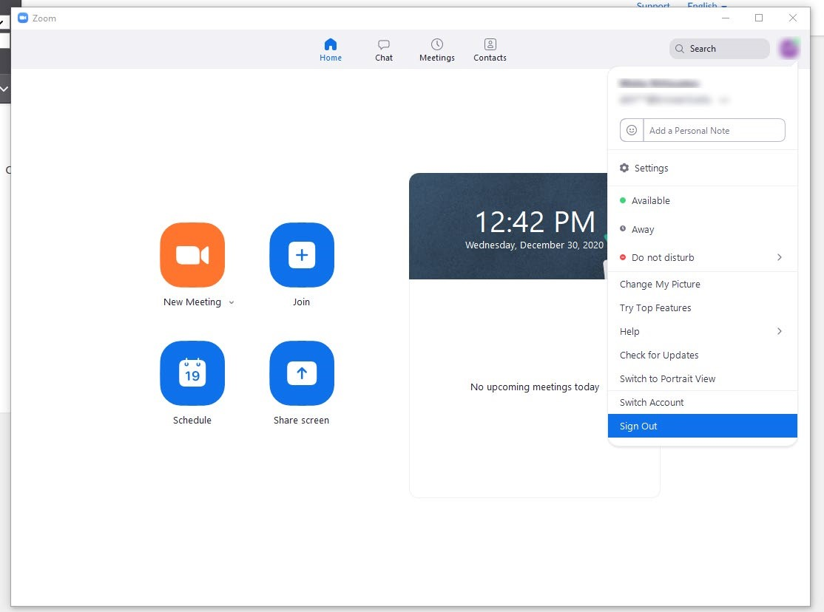

A sign-in window should appear. Click on “Sign In with SSO”.
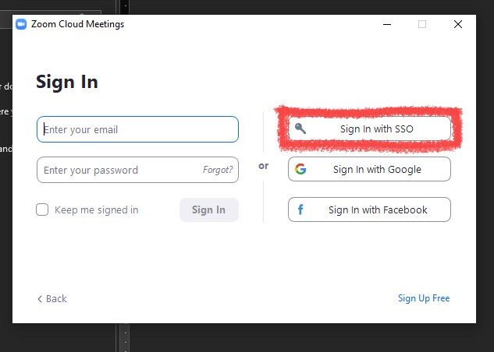

Under “Company Domain”, type in “broward-edu” and click on the Continue button.
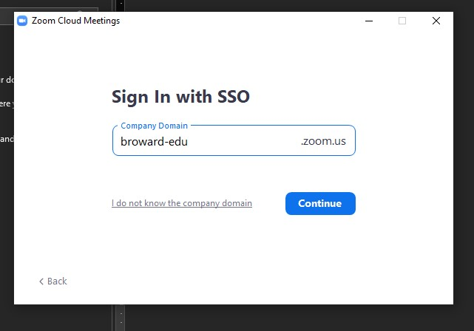
You should be taken to Broward One Access. Sign in with your Broward College credentials.
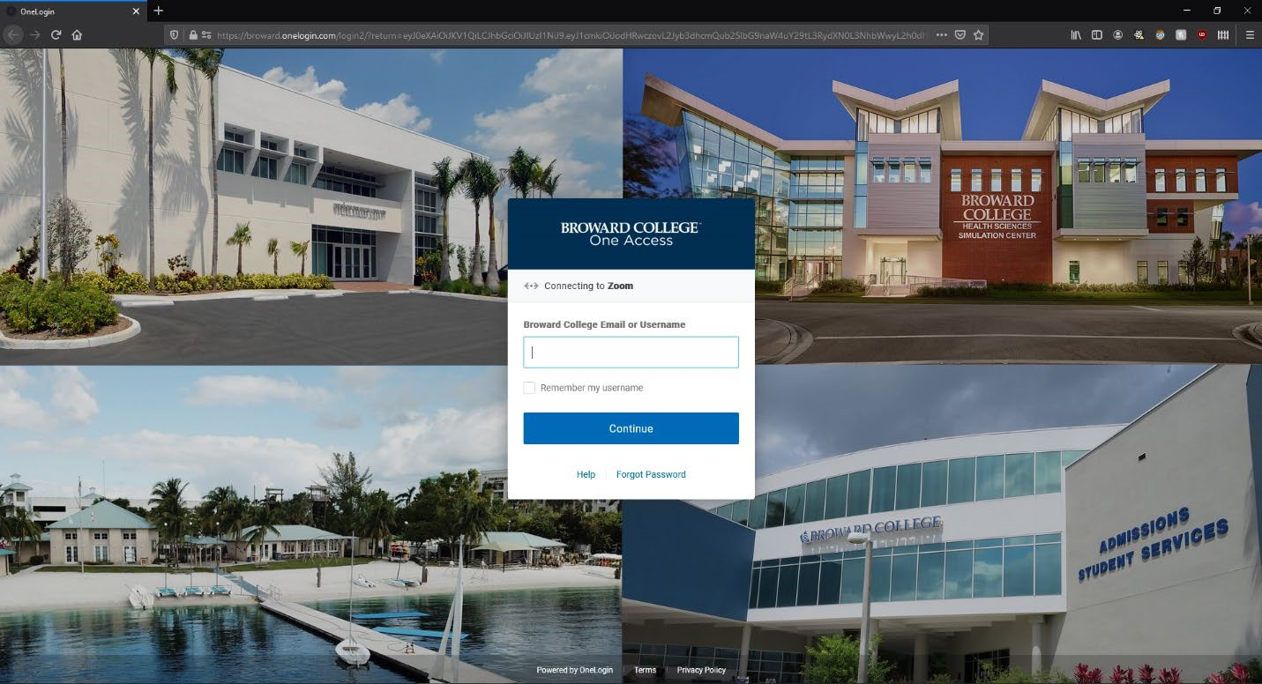
After signing in, it will launch the Zoom application with your Broward College credentials. To confirm this, you can click on the upper right icon and see that “@mail.broward.edu” is being used instead of your personal Zoom account.

Updating your Zoom App
- Sign in to your Zoom App using the steps above.
- Click on your profile image in the top right corner. A drop-down menu will appear.
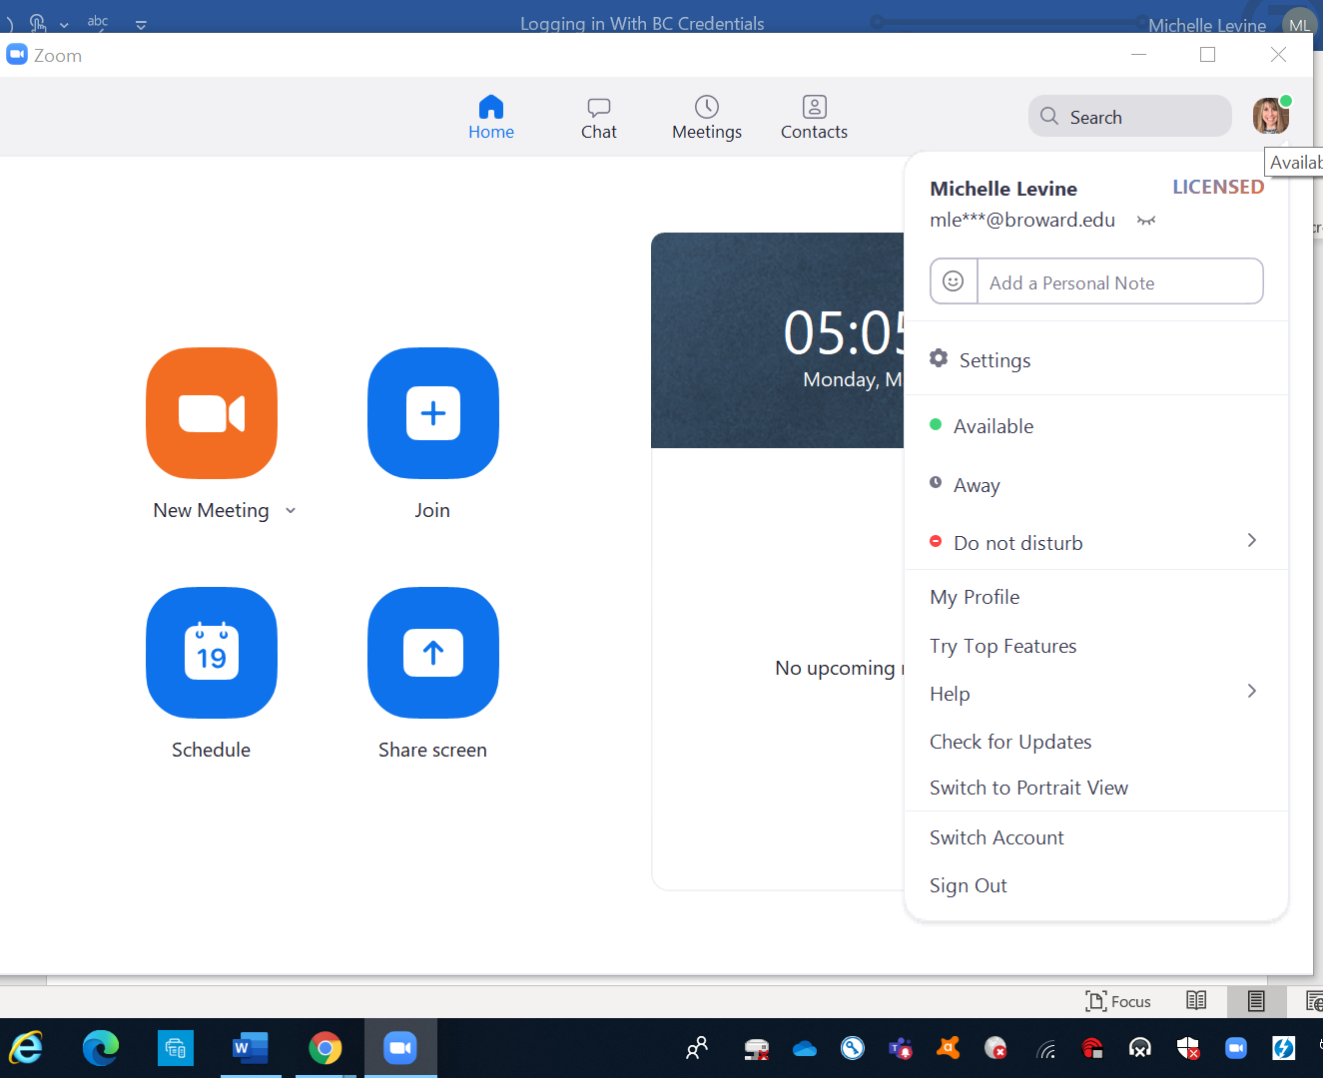
- Choose Check for Updates from the menu.
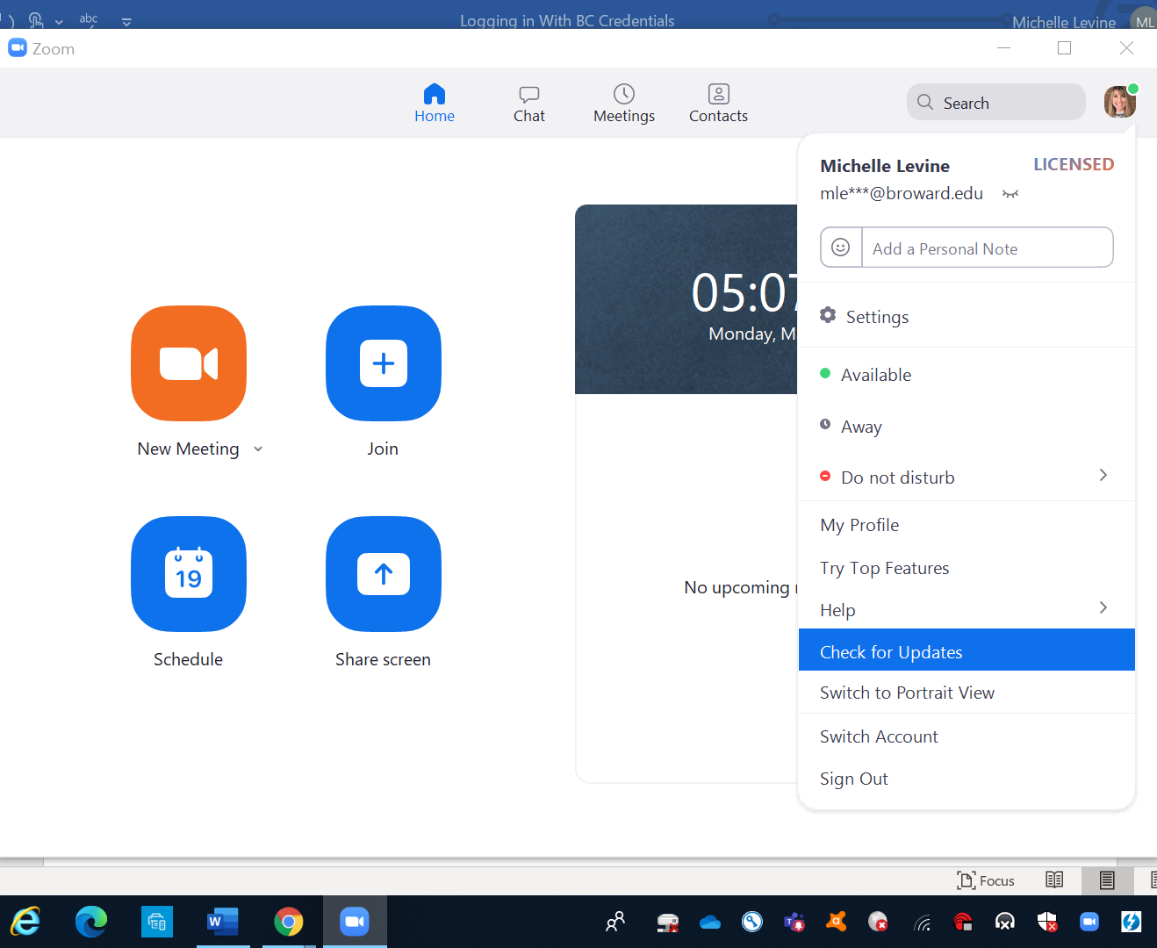
- If your Zoom app is updated, you will see a window that says You are up to date.
If your app is not updated, you will see a window that says Update Available and you can choose Update.
